**Class and Quiz Snapshots:**

**Network and Cyber security( 9 to 11.0)**

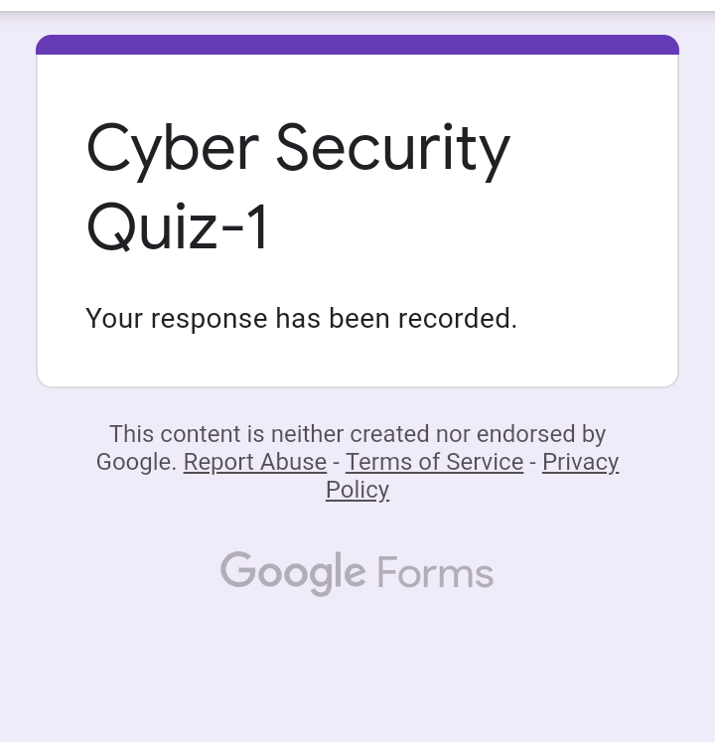

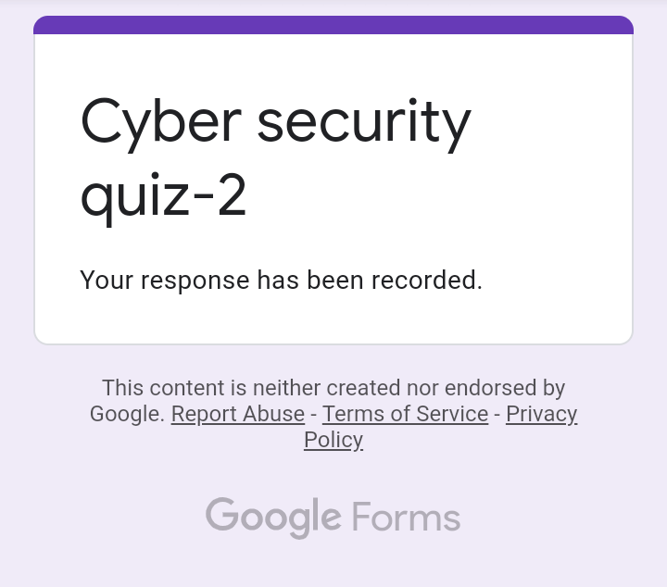

**Data Structures (from 11.30 to 1.00)**

